Exploratory Data Analysis Insights

Summary Statistics

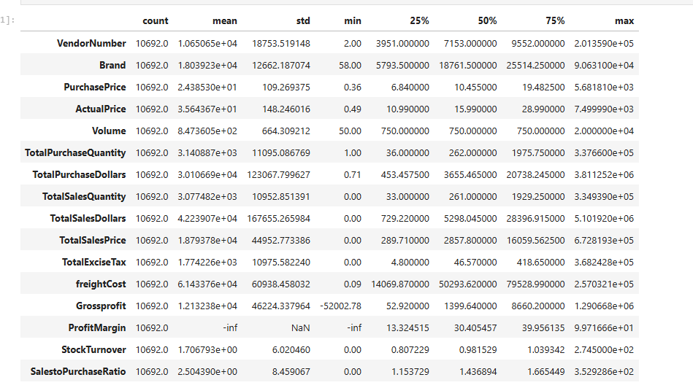

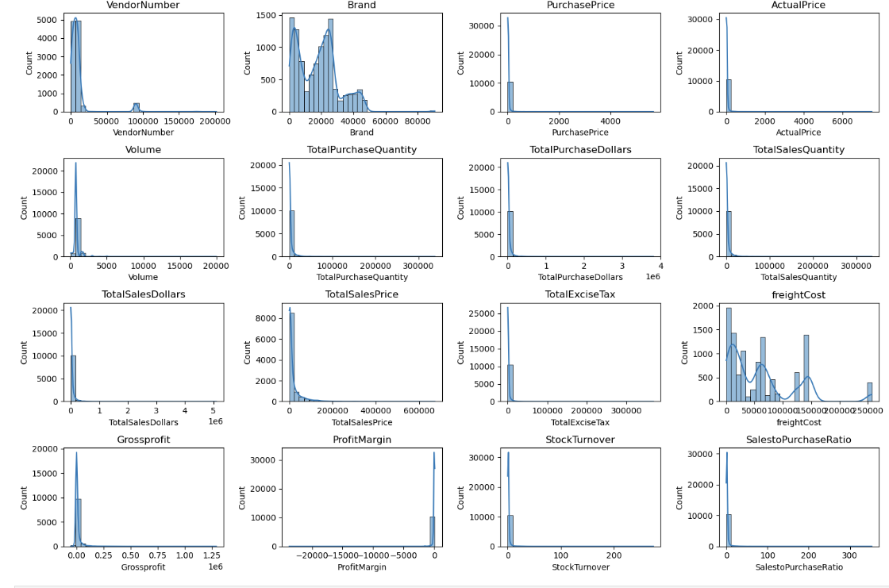

**Negative and Zero Values:**

**Gross Profit:** Minimum of -52,002.78, indicating potential losses due to high costs or heavy discounts. This could be due to selling products at lower prices than their purchase costs.

**Profit Margin:** Has a minimum of -∞, which suggests instances where revenue is zero or even lower than the total cost, leading to extreme negative profit margins.

**Total Sales Quantity and Sales Dollars:** Some products show zero sales, indicating they were purchased but never sold. These may be slow-moving or obsolete stock, leading to inventory inefficiencies.

**Outliers Detected by High Standards Deviations:**

Purchase and Actual Prices: The maximum values(5,681.81 and 7,499.99) are significantly higher than the mean(24.39 &35.64) indicating premium product offerings.

**Freight Cost:** Extreme variation from 0.09 to 257,032.07 suggests logistics inefficiencies,bulk shipments ,or erotic shipping costs across different products.

**Stock Turnover:** Ranges from 0 to 274.5, suggesting some products sell rapidly while others remain unsold for the long periods. A value greater than 1 indicates that sales for a product exceed the purchased quantity due to older stock fulfilling orders.

**Data Filtering**

To enhance the reliability of the insights, we removed inconsistent data points where:

* Gross Profit ≤ 0 (to exclude transactions leading to losses).
* Profit Margin ≤ 0 (to ensure analysis focuses on profitable transactions).
* Total Sales Quantity = 0 (to eliminate inventory that was never sold).

**Correlation Insights**

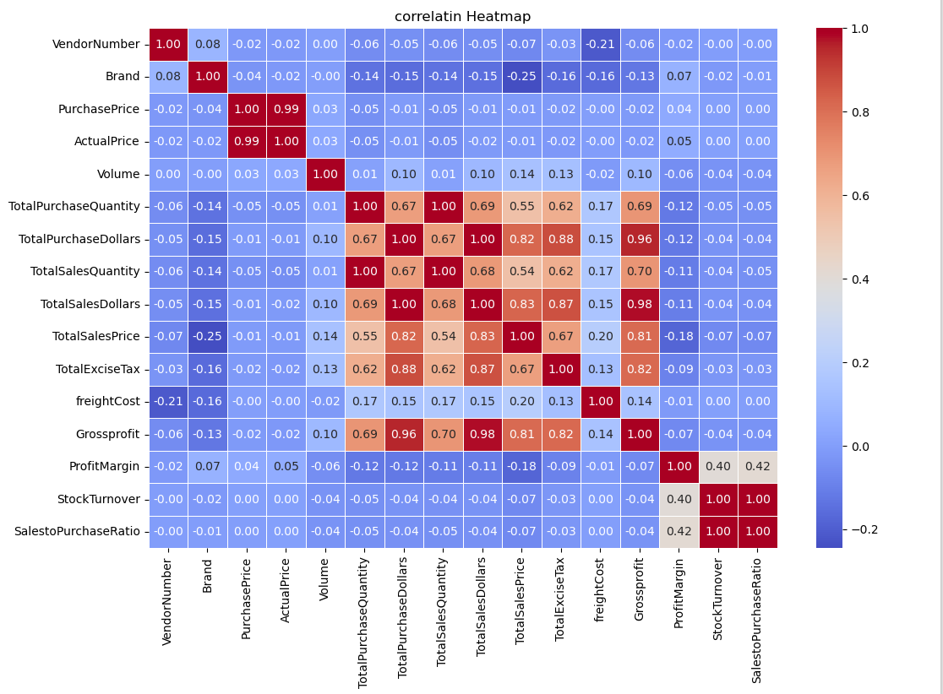

Purchase Price vs. Total Sales Dollars and Gross Profit: Weak correlation (-0.012 and -0.016), indicating that price variations do not significantly impact sales revenue or profit.

**Total Purchase Quantity vs. Total Sales Quantity:** Strong correlation (0.999), confirming efficient inventory turnover.

**Profit Margin vs. Total Sales Price:** Negative correlation (-0.179), suggesting increasing sales prices may lead to reduce margins, possibly due to competitive pricing pressures.

**Stock Turnover vs. Gross Profit & Profit Margin:** Weak negative correlation (-0.038 & -0.055), indicating that faster stock turnover does not necessarily equate to higher profitability.

**Research Questions and key Findings**

**1.Brands for promotional or Pricing Adjustments**

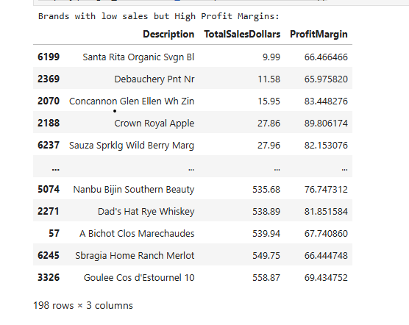

198 brands exhibit lower sales but higher profit margins, which could benefit from targeted marketing, promotions, or price optimizations to increase volume without compromising profitability.

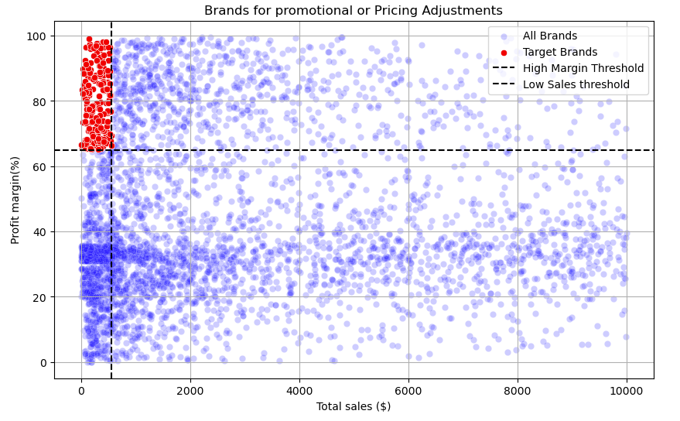

**2.Top Vendors by Sales and Purchase Contribution**

The top 10 vendors contribute 65.69% of total purchases, while the remaining vendors contribute only 34.31%. This over-reliance on a few vendors may introduce risks such as supply chain disruptions, indicating a need for diversification.

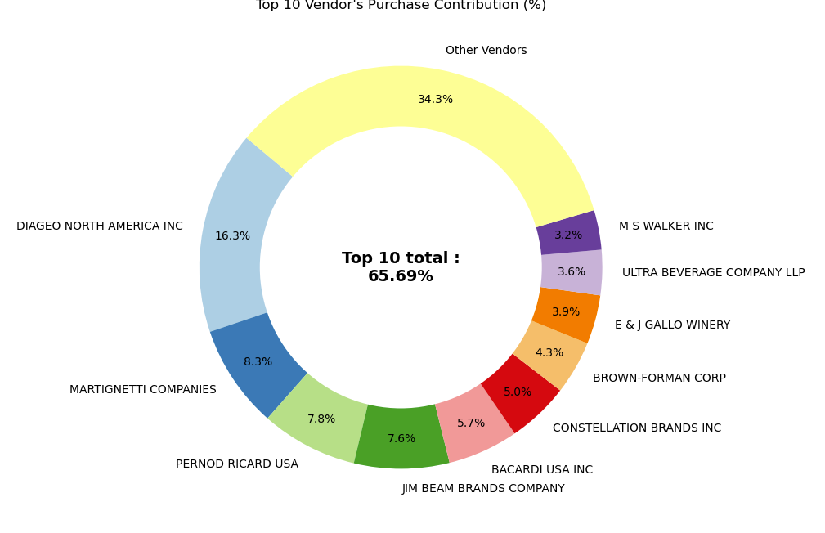

**3.Impact of Bulk Purchasing on cost Savings**

Vendors buying in large quantities receive a 72% lower unit cost ($10.78 per unit vs. higher unit costs in smaller orders).

Bulk Pricing strategies encourage large orders, increasing total sales while maintaining profitability.

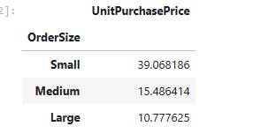

**4.Identifying Vendors with Low Inventory Turnover**

Total Unsold Inventory Capital: $2.71M

Slow-moving inventory increases storage costs, reduces cash flow efficiency, and affects overall profitability.

Identifying vendors with low inventory turnover enables better stock management, minimizing financial strain.

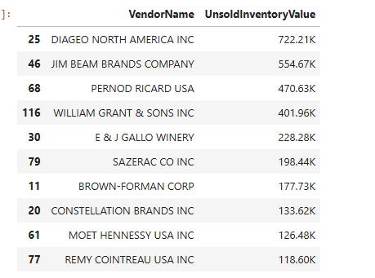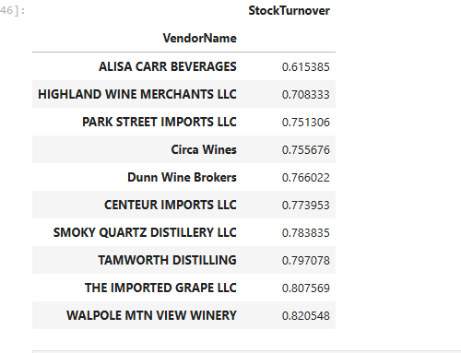

**5.Profit Margin Comparison: High vs. Low-Performing Vendors**

Top Vendors ‘Profit Margin (95% CI): (30.74%,31.61%), Mean:31.17%

Low Vendors ‘Profit Margin (95% CI): (40.48%,42.62%),Mean: 41.55%

Low-Performing vendors maintain higher margins but struggle with sales volumes, indicating potential pricing inefficiencies or market reach issues.

Actionable Insights:

* Top-Performing vendors: Optimize profitability by adjusting pricing, reducing operational costs, or offering bundled promotions.
* Low-Performing vendors: Improve marketing efforts, optimize pricing strategies, and enhance distribution network.

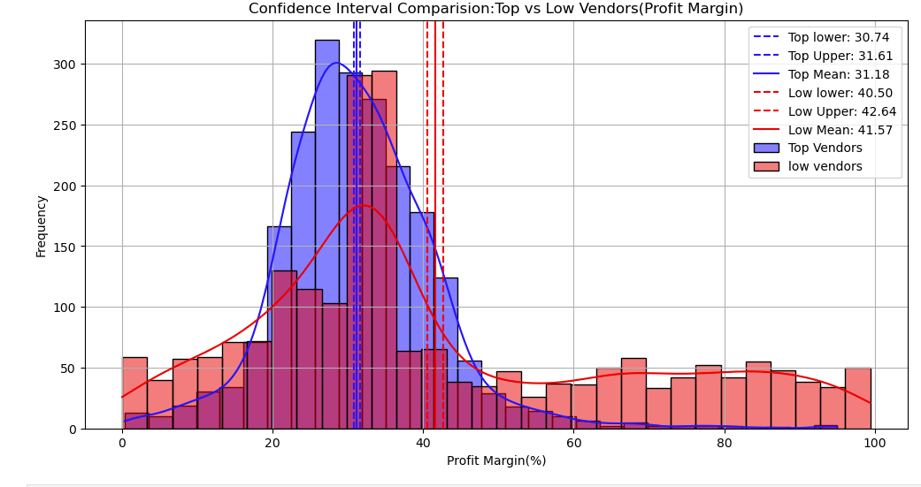

**6.Statistical Validation of Profit Margin Differences**

**Hypothesis Testing:**

$H_{0}$ (Null Hypothesis): No significant difference in profit margins between top and low-performing vendors.

$H1$ (Alternative Hypothesis): A significant difference exists in profit margins between the two vendor groups.

Result: The null hypothesis is rejected, confirming that the two groups operate under distinctly different profitability models.

Implication: High-margin vendors may benefit from better pricing strategies, while top- selling vendors could focus on cost efficiency.

**Final Recommendations**

* Re-evaluate pricing for low-sales, high-margin brands to boost sales volume without sacrificing profitability.
* Diversify vendor partnerships to reduce dependency on a few suppliers and mitigate supply chain risks.
* Leverage bulk purchasing advantages to maintain competitive pricing while optimizing inventory management.
* Optimize slow-moving inventory by adjusting purchase quantities, launching clearance sales, or revising storage strategies.
* Enhance marketing and distribution strategies for low-performing vendors to drive higher sales volumes without compromising profit margins.
* By implementing these recommendations, the company can achieve sustainability profitability, mitigate risks, and enhance overall operational efficiency.